AP CSP Python with CodeX  Functions with Parameters #2 Activity Guide |  | Name:
Review: Functions
Write three or more things you know about parameters and arguments.

Functions with Parameters #2 Examples
Go through the slides for Example #3. Take notes as needed in the space provided.
Go through the slides for Example #4. Take notes as needed in the space provided.
Go through the slides for Example #5. Take notes as needed in the space provided.
Go through the slides that review local variables. Take notes as needed in the space provided.
Local variables.  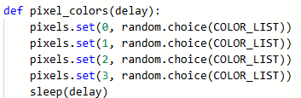 | Answer_Bot program.  Parameter Data Type Local Variable Data Type  Write a possible function call for pixel_colors():
Local variables.  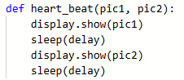 | Heart2_functions program.  Parameter Data Type Local Variable Data Type  Write a possible function call for heart_beat():
Local variables.  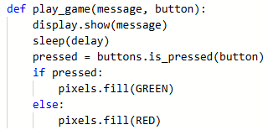 | Display_functions program.  Parameter Data Type Local Variable Data Type  Write a possible function call for play_game():
Check for Understanding:
Function #1:  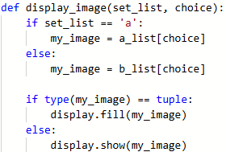 |  | Identify the parameters and local variables :  Parameter Data type  Local Variable Data type  Give a possible function all for the function:
Function #2:  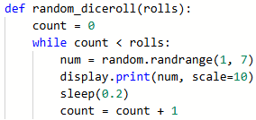 |  | Identify the parameters and local variables :  Parameter Data type  Local Variable Data type  Give a possible function all for the function:
Function #3:  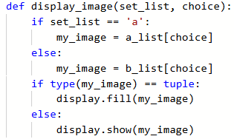 |  | Identify the parameters and local variables :  Parameter Data type  Local Variable Data type  Give a possible function all for the function:
Function #4:  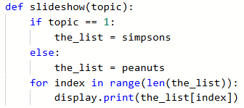 |  | Identify the parameters and local variables :  Parameter Data type  Local Variable Data type  Give a possible function all for the function:

